

**eProject Document**

Cline Management

System

|  |  |
| --- | --- |
| **Group 7** | |
| **Members** | Tran Van Hung - Student1247023(Team Leader)  Dinh Hoang Son - Student1240564 |
| **Instructor** | Lai Duc Chung |
| **Batch** | C1908G2 |
| **Semester** | III |

**🙠 Date of issue 08-16-2021 🙢**

* **Hardware and Software Requirements**
* **Minimum Hardware Requirements**
* CPU: should use core i5 or higher.
* RAM: 4GB RAM or more is recommended.
* Hard Disk: 20 GB.
* OS: Windows 10 and up.
* Chrome new version.
* Internet Information Services (IIS) 10.0.22377.1000
* **Recommended Hardware Requirements**
* CPU: should use core i5 or higher.
* RAM: 4GB RAM or more is recommended.
* Hard Disk: 20 GB.
* OS: Windows 10 and up.
* Chrome new version.
* Internet Information Services (IIS) 10.0.22377.1000
* **Software Requirements**
* Environment: Microsoft .NET Framework 4.7.2
* Database Management System: Microsoft SQL Server Management Studio 18
* IDE: Microsoft Visual Studio 2019 preview
* Web Server: Internet Information Services (IIS 10.0.22377.1000)
* Chrome new version.

**Summary :**

+ Extracting files “**Cline_Management_Group7**”.

+ Copy extracted files and folder such as Database, Source Code to the drive that is enough space for them. For example Drive D or E.

However, you should copy “ClineManagement” folder to the “C:\Inetpub\wwwroot\” folder on the local drive.

+ **Computer should have internet to execute send e-mail to member or customer.**

* **Install Application “Cline Management”.**
* **1 :Install project**
* **Step 1 :** Open Visual studio 2019 > File > Open > Project/solution > Find and open cline01bkap.sln

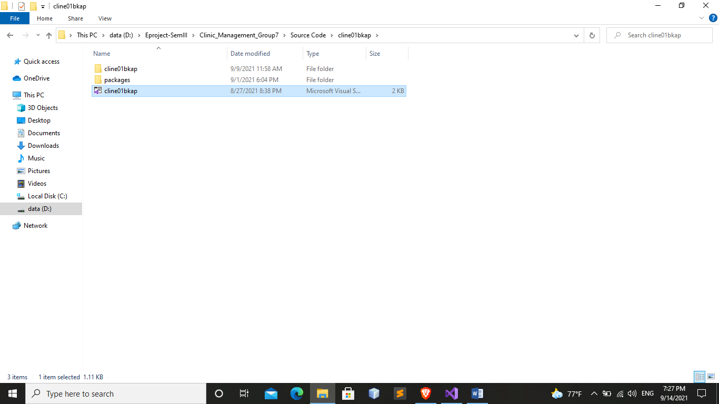

* **Step 2 :** Login in SQL Server 20019 :
* Enter information necessary :
* Authentication : SQL Server Authentication.
* Login and password of your computer.
* note recommend using account:sa, password is :1234$
* Click button “Connect”.

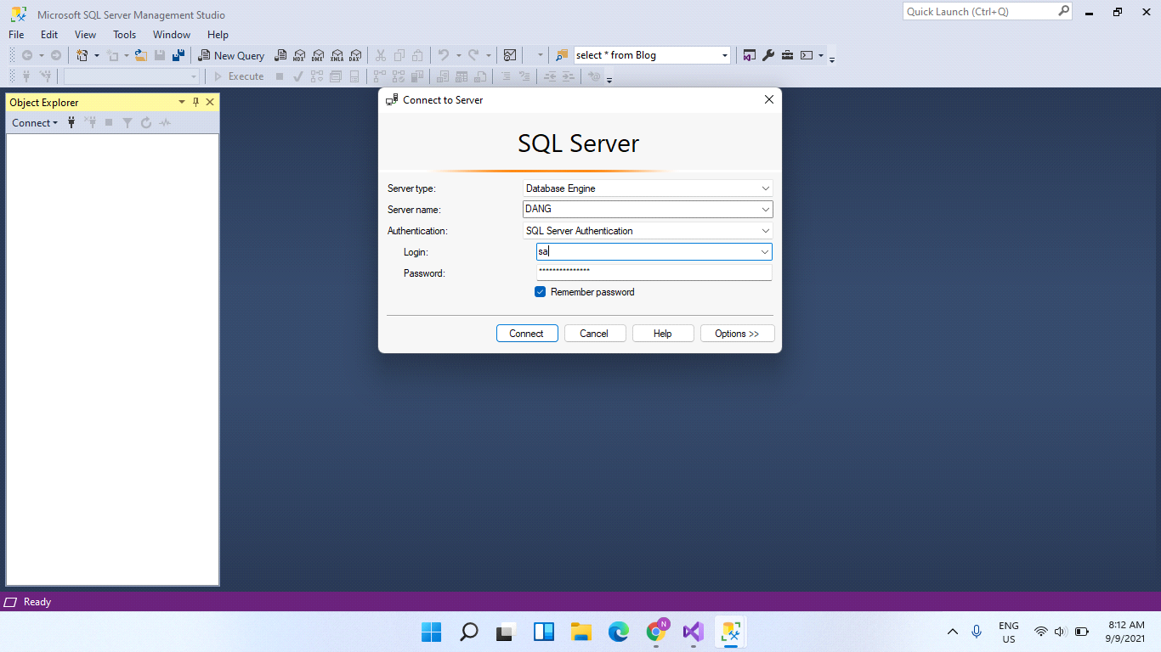

* **Step 3 :**
* you find and open file SQL_Clinic_management.sql :

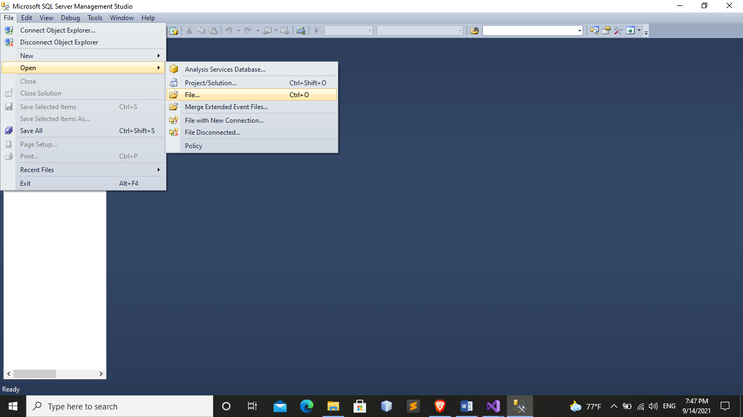

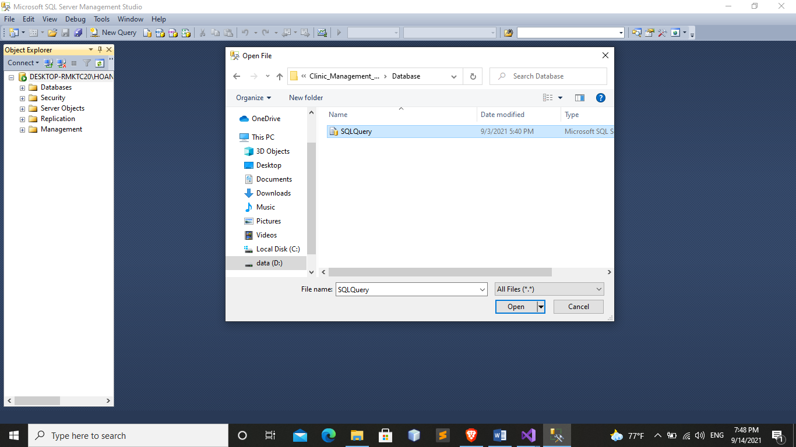

* you ctrl+A and press f5:

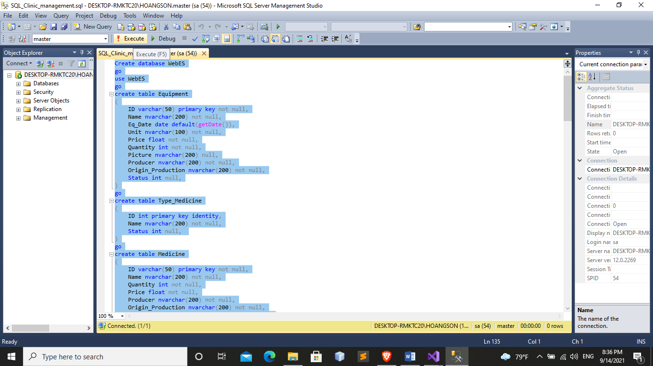

* **Step 4 :**
  1. - In visual studio 2019 you click Models > WebESEntities.edmx> Click Update Model from Database…

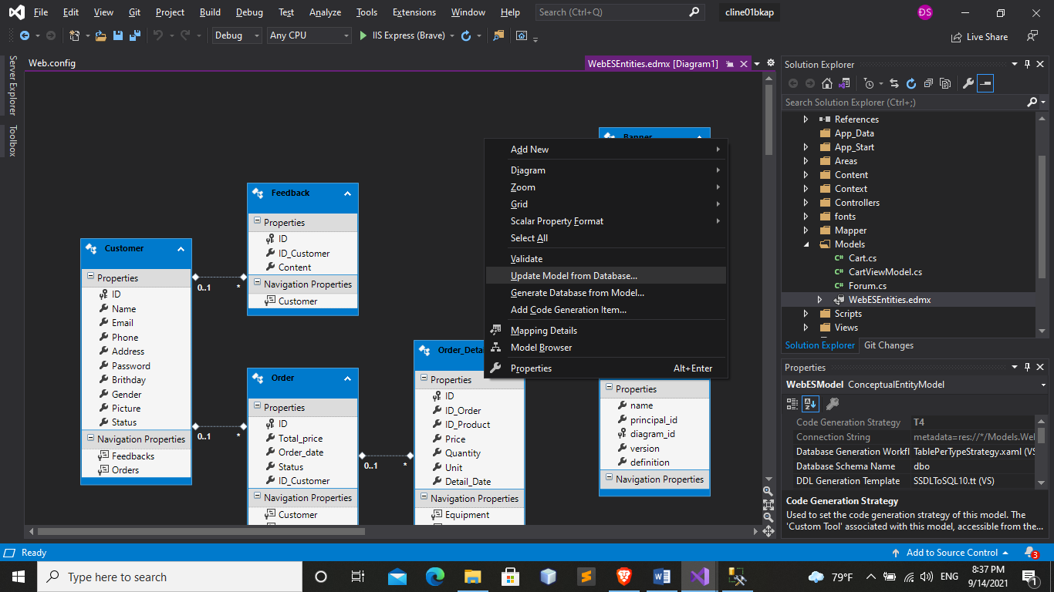

* Click New Connection… then login account SQL Server 20019 and Choose Select or enter a database name at Connect at database -> choose WebES -> click Test Connection

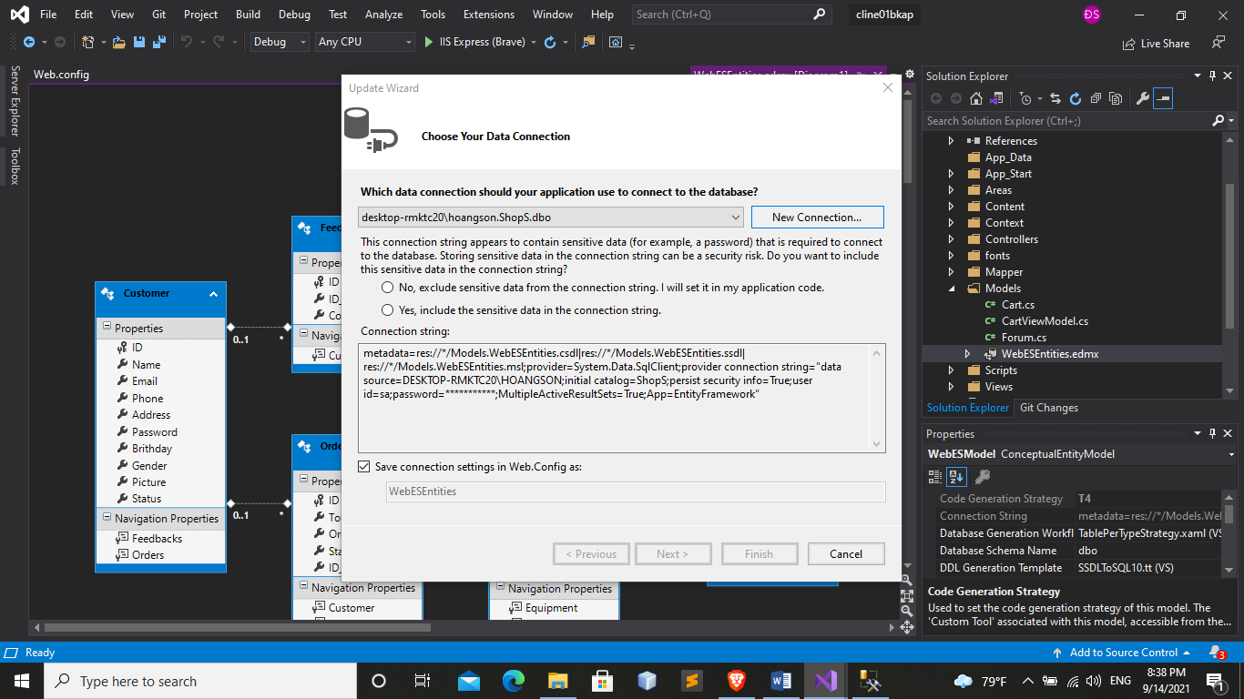

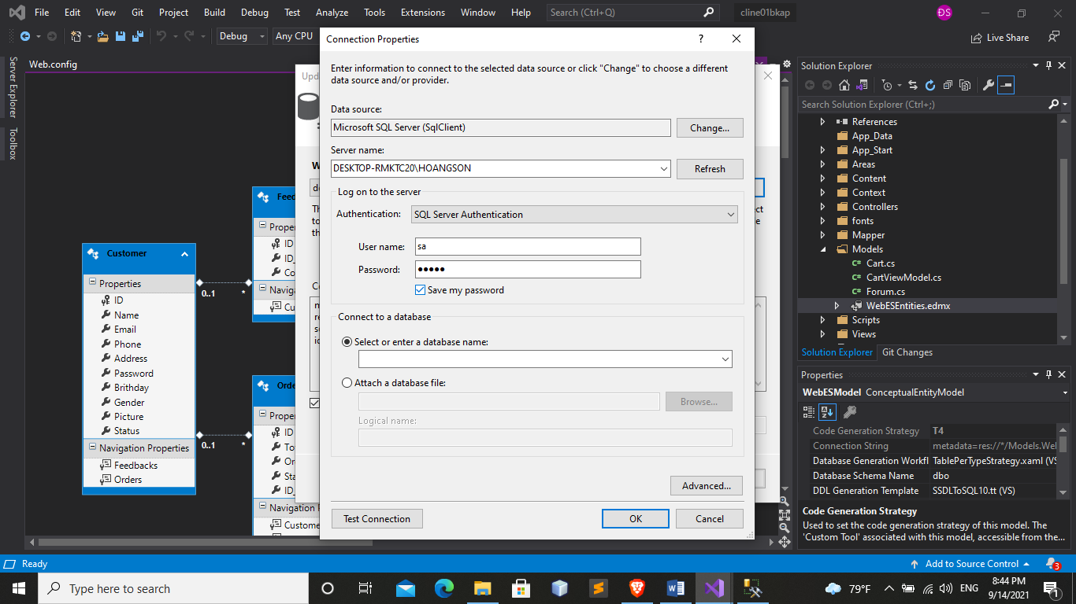

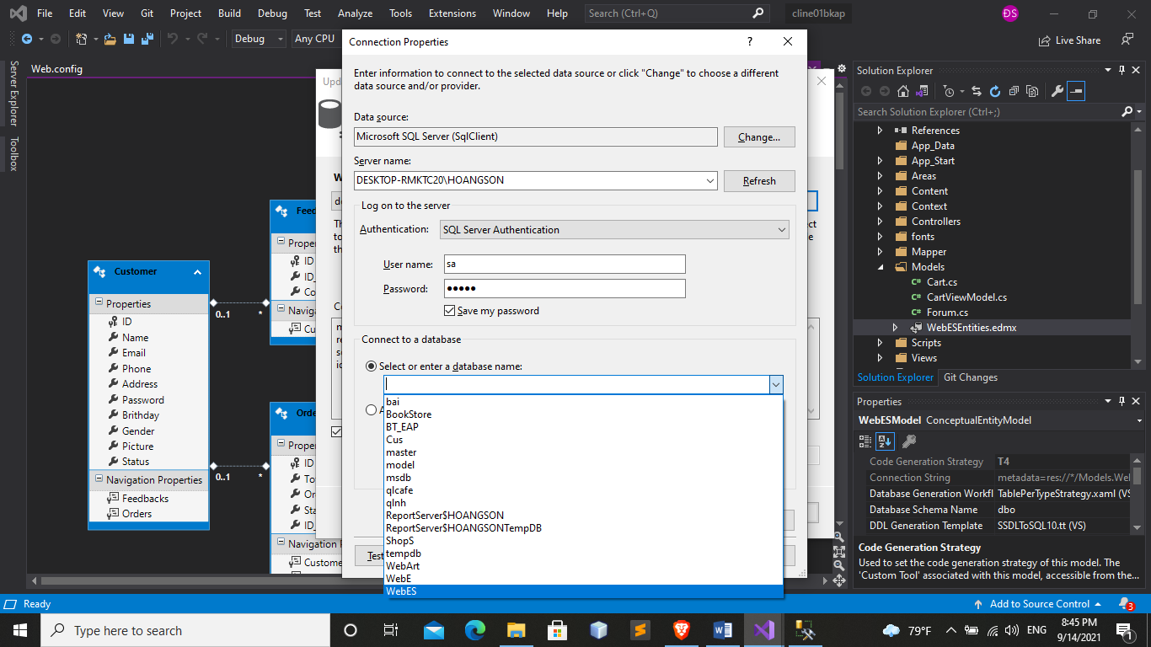

-If your screen shows this is correct, otherwise go back to Step **4**

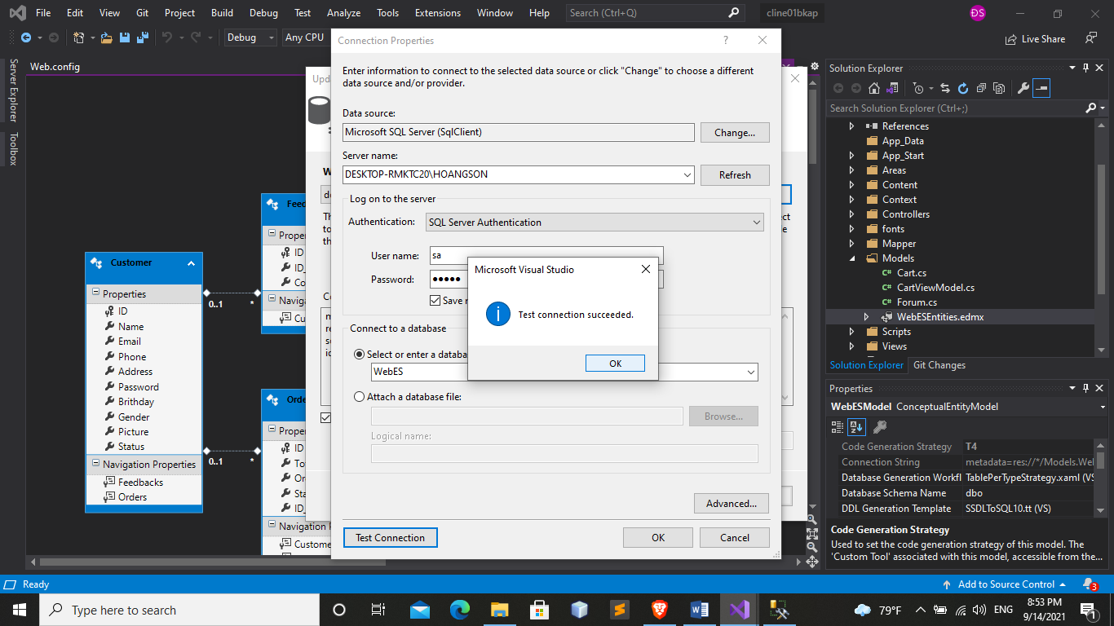

* You click OK -> OK -> Click Yes, include the sensitive data… ->Next->Finish

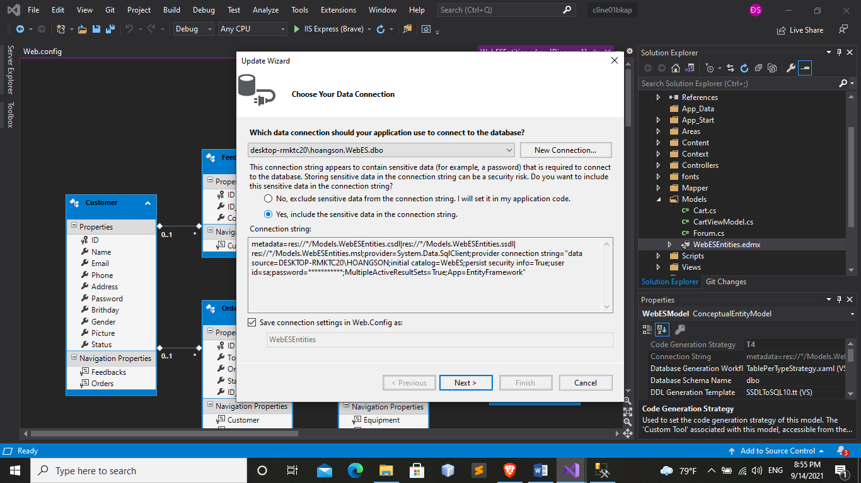

* **Step 5**

**run on chrome browser**

* go to visual studio and click on IIS Express (Google Chrome)

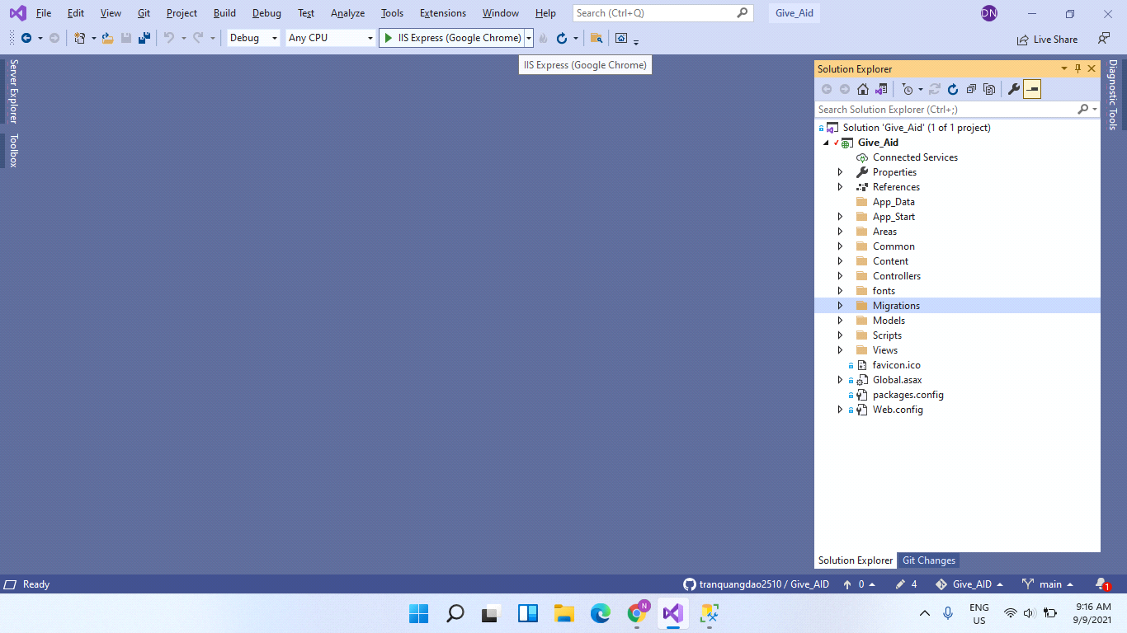

* This is the user interface when the administrator has not added the data yet

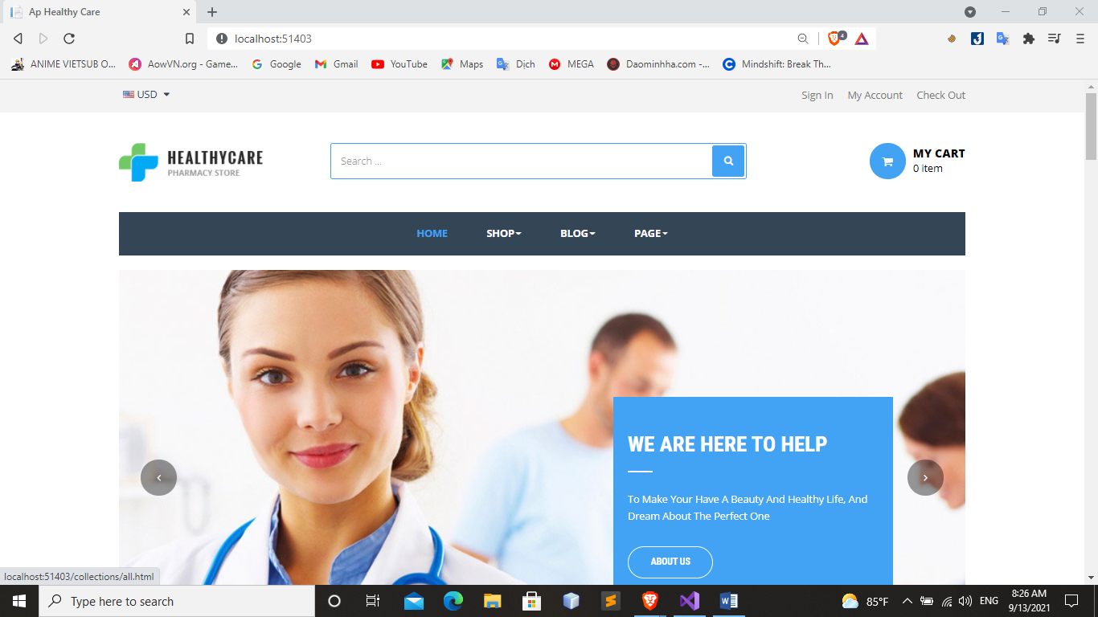

* on the url, please enter /Admin/ to be able to access the admin page

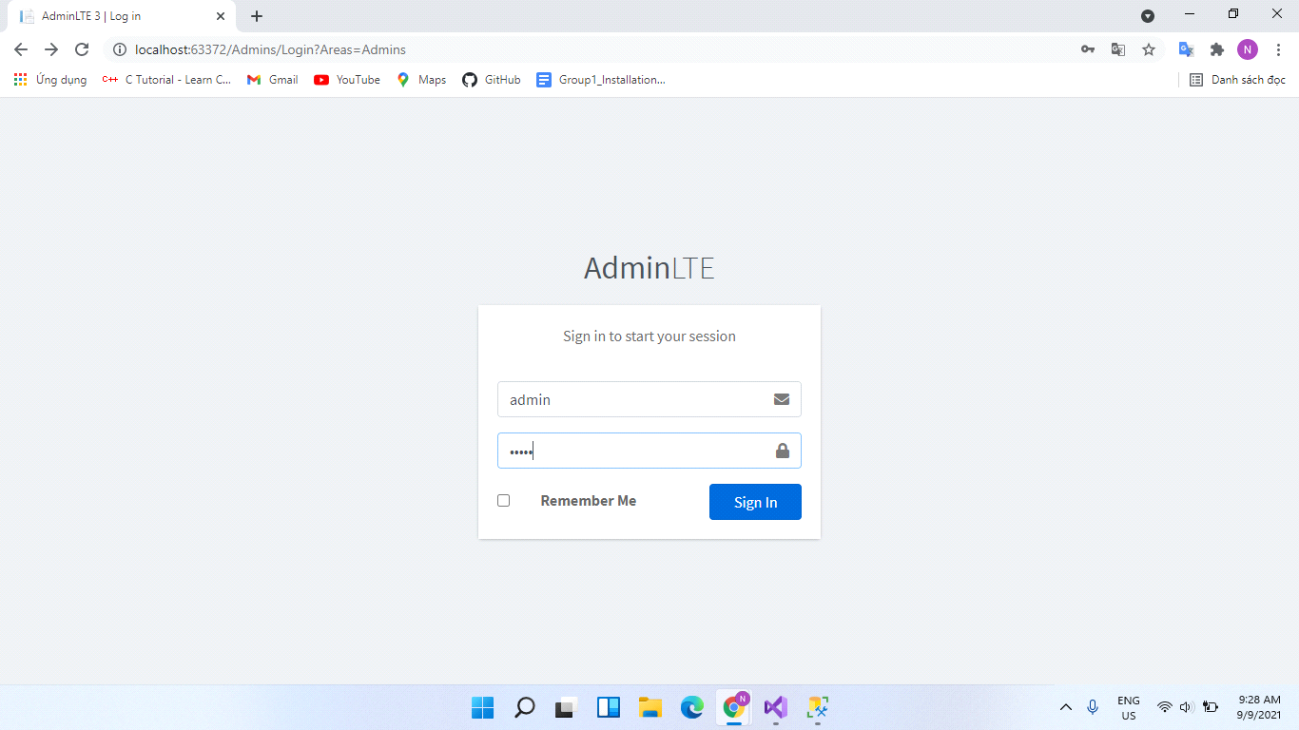

* when you go to the admin page you can manipulate data such as: add edit delete update ...

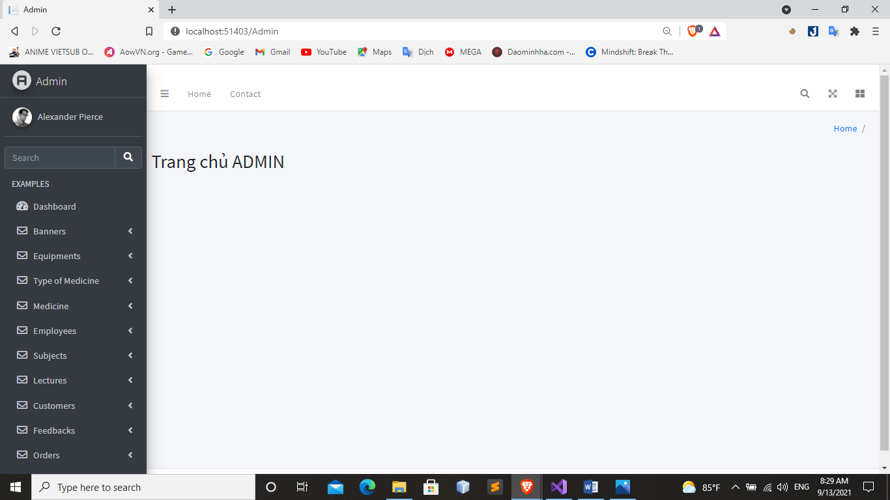

Note:

* when you add data in admin page data will be dumped in user page
* Have fun using it

**THE END**